Ventilator Using Cam Shaft Mechanism

COVID19 shocked humankind with a wave of unexpected health crisis in 2019 2020 and 2021 and still continues to plague humankind in some region or the other. As COVID family of viruses majorly affect the lungs while limiting lung capacity and causing breathing problems, ventilator development and research has gained particular importance.
Human lungs use the reverse pressure generated by contraction motion of the diaphragm to suck in air for breathing. A contradictory motion is used by a ventilator to inflate the lungs by pumping type motion.
A ventilator mechanism must be able to deliver in the range of 10 – 30 breaths per minute, with the ability to adjust rising increments in sets of 2. Along with this the ventilator must have the ability to adjust the air volume pushed into lungs in each breath. The last but now the least is the setting to adjust the time duration for inhalation to exhalation ratio.
Apart from this the ventilator must be able to monitor the patients blood oxygen level and exhaled lung pressure to avoid over/under air pressure simultaneously. The ventilator we here design and develop using a controller that encompasses all these requirements to develop a reliable yet affordable DIY ventilator to help in times of pandemic.
We here use a silicon ventilator bag coupled driven by Stepper motor with single side push mechanism to push the ventilator bag. For this we hereby make use of cam Shaft mechanism to achieve inflation and deflation. We make use of a stepper motor to drive the mechanism.

We connect the stepper motor shaft to a cam in order to convert rotary motion into linear motion here. The cam is oval on shape designed to push one end of the pressing arm upwards. The pressing arm is mounted on top of the ventilator bag and connected to joint mechanism in between. This creates a seesaw like mechanism.

Now as stepper motor rotates and pushes the arm upwards on one site, it presses against the bag on other end. Now the rate of inflation and deflation depends on the RPM of motor. As per settings provided we vary the motor RPM to achieve desired BPM rate. We use toggle switch for switching and a variable pot to adjust the breath length and the BPM value for the patient.
Our system makes use of blood oxygen sensor along with sensitive pressure sensor to monitor the necessary vitals of the patient and display on a mini screen. Also an emergency buzzer alert is fitted in the system to sound an alert as soon as any anomaly is detected.
The entire system is driven by a controller circuitry to achieve desired results and to assist patients in COVID pandemic and other emergency situations.

Components
- Stepper Motor
- Ventilator bag
- Valve and Fittings
- Press Arm
- Blood Oxygen Sensor
- Pressure Sensor
- Controller Circuitry
- Hinges
- Shaft and Bearings
- Support Rods
- Pipes and Joints
- Base Frame
- Supporting Frame
- Mounts and Joints
- Nuts and Bolts
- Screws and Connectors

Block Diagrams
Side View
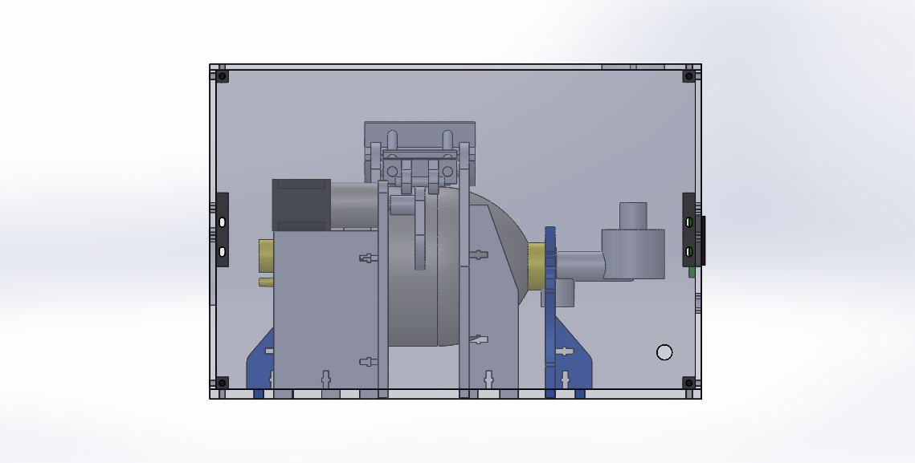
Top View
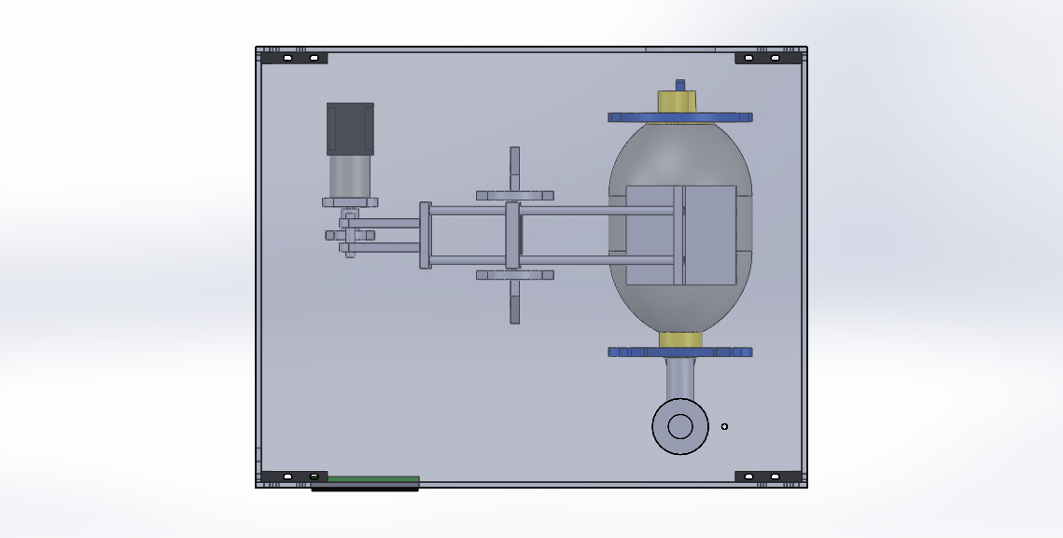

3D Views
